
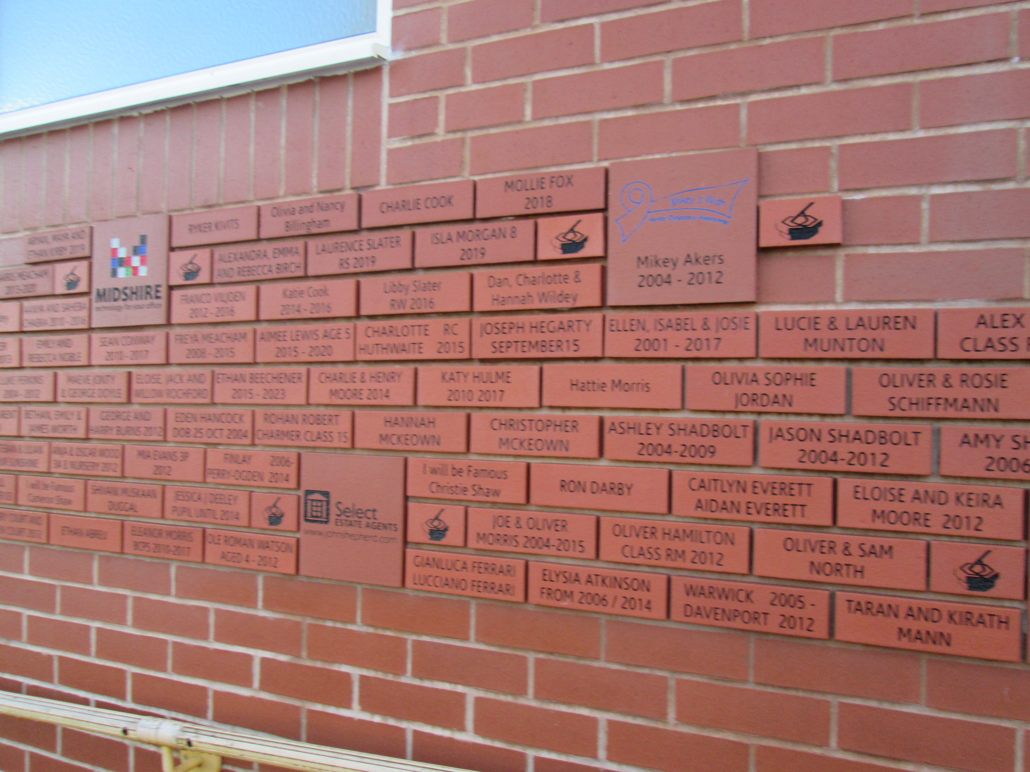

Leave a legacy at our school!
Buy a personalised brick and help create a space you and your child can be proud of, today and for the future.
Create a lasting memory of your child’s primary school time
Our permanent Wall of Fame on the outside wall of our swimming pool.
The personalised brick display offers a unique way to celebrate your connection to our school. Whether you choose to feature your name, your child’s or grandchild’s name, or a heartfelt message, each brick will serve as a lasting tribute to those who are part of our school’s story—past or present - all for £27.

To order: Please complete below order form and return electronically to: s2brick@balsall-common.solihull.sch.uk or hand in to our Front Office.
Payment through ParentPay. For multiple children and alumni, please email s2brick@balsall-common.solihull.sch.uk for bank details.
Order deadlines
Autumn: Thursday 23rd October 2025
Spring: Thursday 26th March 2026
Summer: Thursday 21st May 2026

Thank you for your continuing support,
Balsall Common Primary School Academy

Buy A Brick Order Form - £27 per brick
Name:
Full Postal Address: | ______________________________________________________  ___________________________________ Post code: ________
Phone Number:
Email Address:
Child’s Name:
Child’s Class:
Brick Wording
Each brick has space for 2 lines of text with a maximum of 16 characters per line. Punctuation and spaces count as characters.
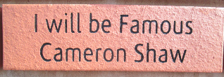
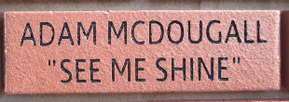
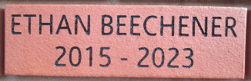
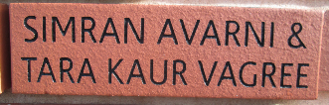
For example:

Balsall Common Primary School Academy reserve the right to reject wording that is felt to be inappropriate. Please check all spelling as we cannot be responsible for mistakes on this form.

